**Cars24 Inventory Data analysis using Power BI.**

**About:** CARS24 is an Indian multinational online [used car](https://en.wikipedia.org/wiki/Used_car" \o "Used car) marketplace headquartered in [Gurgaon](https://en.wikipedia.org/wiki/Gurgaon" \o "Gurgaon).

**Dataset:** <https://www.kaggle.com/datasets/balajimummidi/used-cars-in-cars24>

The dataset contains data from 5 major cities which include Hyderabad, New Delhi, Mumbai, Bangalore, Chennai.

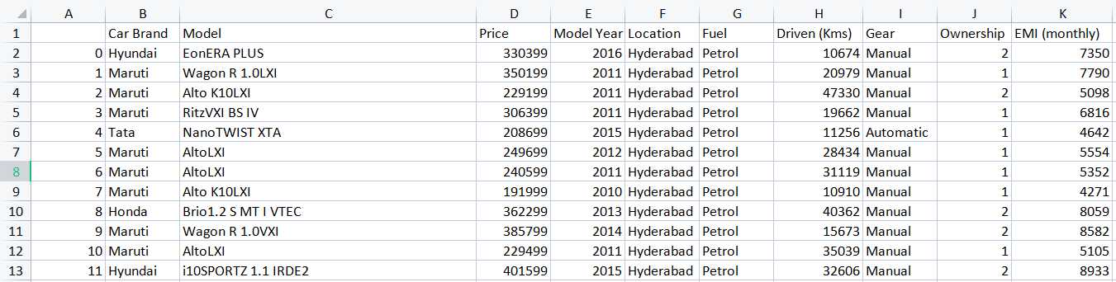

Brands - Maruti, Hyundai ,Tata etc.

Model - WagonR, Alto etc

Price - In INR

Model Year - Make Year

Location - Hyderabad, New Delhi, Mumbai, Bangalore, Chennai.

Fuel - Petrol, Diesel, Ev etc.

Driven - Distance driven in Kms.

Gear - Automatic or Manual

Ownership - 1st owner, 2nd owner etc.

EMI - Monthly Amount to buy the car.

**Power BI dashboard:**

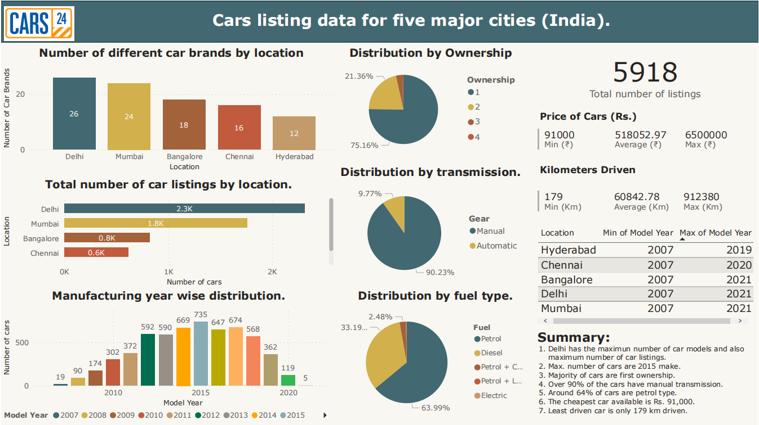

**Summary:**

1. Delhi has the maximum number of car models and also maximum number of car listings.

2. Max. number of cars are 2015 make.

3. Majority of cars are first ownership.

4. Over 90% of the cars have manual transmission.

5. Around 64% of cars are petrol type.

6. The cheapest car available is Rs. 91,000.

7. Least driven car is only 179 km driven.